Practical – 3
Study and implement PCA in python.
- What is Principle Component Analysis (PCA) ?
PCA (Principal Component Analysis) is a dimensionality reduction technique and helps us to reduce the number of features in a dataset while keeping the most important information. It changes complex datasets by transforming correlated features into a smaller set of uncorrelated components.
- How PCA works?
PCA uses linear algebra to transform data into new features called principal components. It finds these by calculating eigenvectors (directions) and eigenvalues (importance) from the covariance matrix. PCA selects the top components with the highest eigenvalues and projects the data onto them simplify the dataset.
Note: It prioritizes the directions where the data varies the most because more variation = more useful information.
Imagine you’re looking at a messy cloud of data points like stars in the sky and want to simplify it. PCA helps you find the "most important angles" to view this cloud so you don’t miss the big patterns.

- Implementation of PCA using Eigenvalues and Eigenvectors:
Step 1: Dataset Preparation
We are using wine data for this practical it contains 13 features and 178 rows
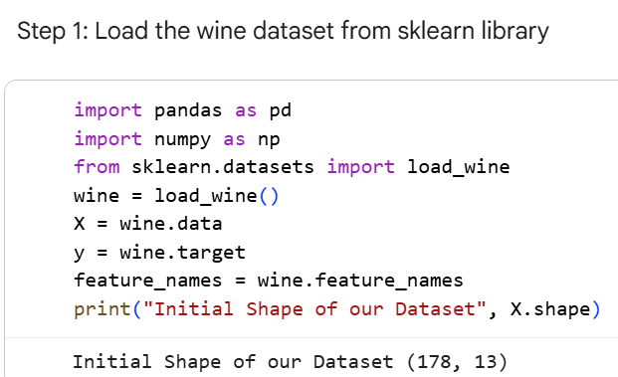
Step 2: Perform Standardization on the dataset:-

We need to perform standardization as the PCA works on variance and if the data is not standardized then it can create a greate problem to our Analysis.

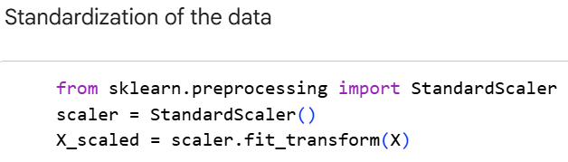

Step 3: Compute the Covariance Matrix

Calculate the covariance matrix to understand relationships between features. We do transpose of our dataset as the numpy expects features in rows.

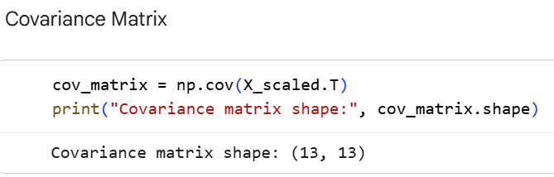

Step 4: Compute Eigenvalues and Eigenvectors

Find eigenvalues (variance amount) and eigenvectors (principal directions) of the covariance matrix.

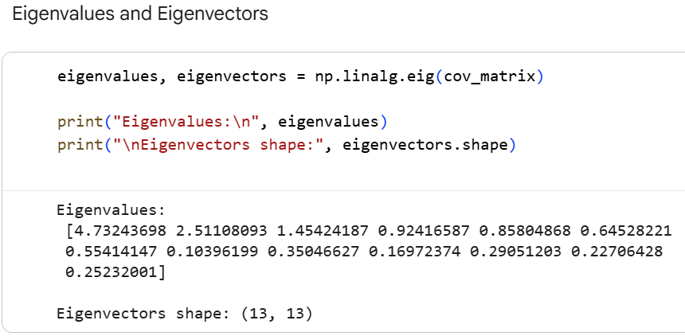

Step 5: Sort Eigenvalues and Eigenvectors:-

Arrange them in descending order of eigenvalues to rank principal components by importance

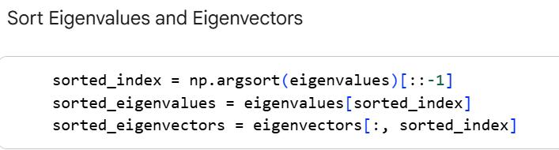

Step 6: Calculate Explained Variance Ratio:-

Determine how much variance each principal component explains.

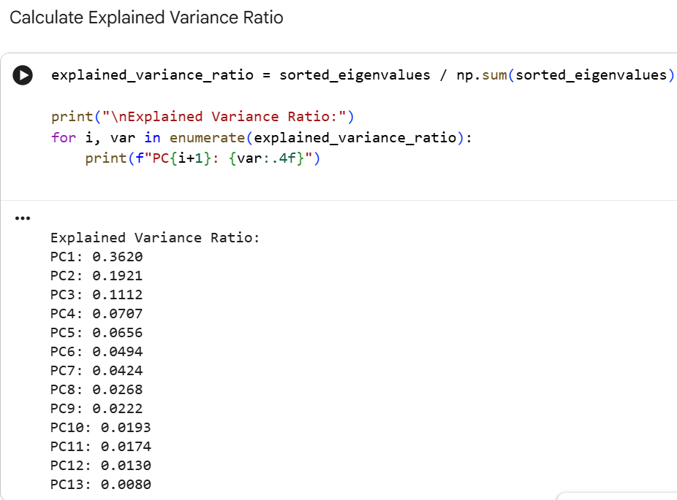

Step 7: Select Top k Principal Components

Choose the top eigenvectors corresponding to the largest eigenvalues for dimensionality reduction.

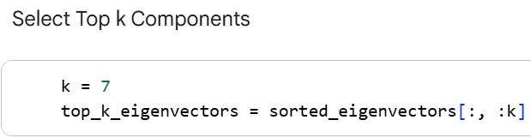

Step 8: Transform the Data (Projection) and Print Dimensions:

Project the standardized data onto the selected principal components using dot product. Print the dimensions of the reduced data.

